[InSTEDD - Innovative Support To Emergencies, Diseases and Disasters](http://instedd.org)

[Work With Us](http://instedd.org/our-work/consulting/) [Contact Us](http://instedd.org/contact-us)Bottom of Form

**[Technologies](http://instedd.org/technologies/)**

**Nuntium**

Nuntium is a tool that allows anyone to build robust and scalable messaging applications.

**What is Nuntium?**

Nuntium is a set of services and clients that allow anyone to build SMS-based applications with uses that range from simple modem-based needs to countrywide deployments integrated with wireless operators. It is used every day in mission-critical applications including ministries of health or in crises such as in Haiti.

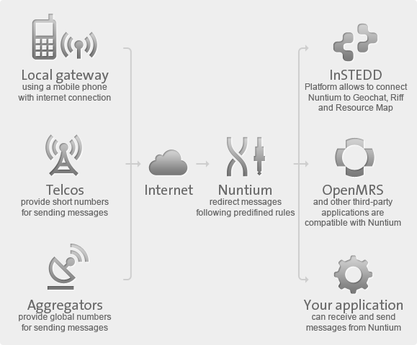

**Why Use Nuntium?**

**Focus your efforts on the uniqueness of your application, let Nuntium take it further**. Text message-based applications are proven to be adequate in low-resource settings. But not everyone needs to re-build the messaging infrastructure required to take applications to scale. Nuntium takes care of delivering and dispatching messages in scenarios common to humanitarian work, and has a simple API that you can use across multiple languages and platforms.

InSTEDD’s technologies such as [GeoChat](http://instedd.org/technologies/geochat/) and [Riff](http://instedd.org/technologies/riff/) exchange thousands of messages for mission-critical applications using Nuntium. Nuntium is also integrated with [OpenMRS](http://openmrs.org/" \t "_blank) and other humanitarian applications. Learn about Nuntium’s features and contact us if you are a mobile operator looking to expand your services into mHealth and development applications.

**How does Nuntium work?**

Nuntium dispatches messages reliably to and from different sources: from SMS aggregators such as Clickatell, direct connections with wireless operators, to GSM modems and Skype via a downloadable local gateway program that runs on any computer. This allows you to start small and grow the scale of your application without changing its core code. It also integrates email and twitter, and takes care of reliable queuing, security, retries, and throttling.

**Features:**

* You can start small with a modem plugged into a computer, or you can use Skype, Clickatell or other aggregators and grow to scalable direct connections to mobile operators.
* Beyond SMS, you can use email, twitter and xmpp for messages allowing you or your users to chose the best channel for the scenario
* Protects against missed connections or server failures through persistent queues
* Self test and code running constantly to ensure reliability
* Connect to multiple phone operators via smpp and ivn sec tunnels (?)
* Routing and relabeling across phone companies
* Can throttle messages or set blackout times to avoid imposing unnecessary stress on mobile operators

**Benefits**

* Your application deals with a simple protocol (HTTP, might be another one) instead of communicating directly with the cellphone company.
* You have a complete trace of what happened to each message.
* You can specify [custom routing logic](http://code.google.com/p/nuntium/wiki/Routing).
* You can change the routing logic without touching a single line in your application’s source code.
* You don’t have to repeat this logic in every application that needs to send and receive messages.
* You don’t need to change your architecture as it grows.

**Take a Tour**

See how Nuntium can help your developers build better messaging applications:



* [logo-nuntium-complete](http://nuntium.instedd.org/)
  + [Start using it now](http://nuntium.instedd.org/)
  + [Already a user? Sign in »](http://nuntium.instedd.org/)
* **Community**
  + [Join our user group](http://tech.groups.yahoo.com/group/nuntiumusers/)
  + [Contribute to the Code](http://code.google.com/p/nuntium/)
* **Screenshot**

[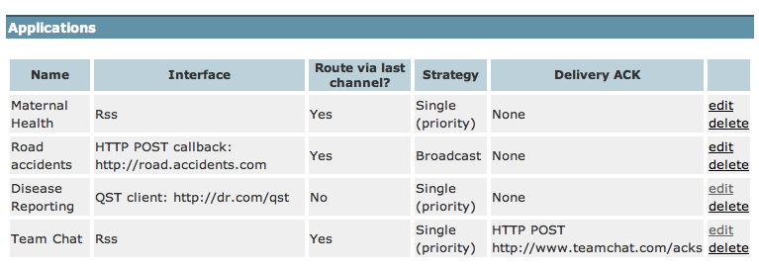](http://instedd.org/wp-content/uploads/2010/08/nuntium-app-2.png)

* [About Us](http://instedd.org/about-us/)
  + [Overview](http://instedd.org/about-us/)
  + [Guiding Principles](http://instedd.org/about-us/guiding-principles/)
  + [Team](http://instedd.org/about-us/team/)
  + [History](http://instedd.org/about-us/history/)
  + [Opportunities](http://instedd.org/about-us/opportunities/)
  + [Global Ambassadors Program](http://instedd.org/about-us/global-ambassadors-program/)
* [Our Work](http://instedd.org/our-work/)
  + [Approach](http://instedd.org/our-work/approach/)
  + [Projects](http://instedd.org/our-work/projects/)
* [iLabs](http://instedd.org/ilabs/)
  + [Overview](http://instedd.org/ilabs/)
  + [Southeast Asia](http://instedd.org/ilabs/southeast-asia/)
  + [Latin America](http://instedd.org/ilabs/latin-america/)
* [Technologies](http://instedd.org/technologies/)
  + [Overview](http://instedd.org/technologies/)
  + [GeoChat](http://instedd.org/technologies/geochat/)
  + [Pollit](http://instedd.org/technologies/pollit/)
  + [mBuilder](http://instedd.org/technologies/mbuilder/)
  + [Mesh4X](http://instedd.org/technologies/mesh4x/)
  + [Nuntium](http://instedd.org/technologies/nuntium/)
  + [Remindem](http://instedd.org/technologies/remindem/)
  + [Reporting Wheel](http://instedd.org/technologies/reporting-wheel/)
  + [Resource Map](http://instedd.org/technologies/resource-map/)
  + [Riff](http://instedd.org/technologies/riff/)
  + [Seentags](http://instedd.org/technologies/seentags/)
  + [Veegilo](http://instedd.org/technologies/veegilo/)
  + [Verboice](http://instedd.org/technologies/verboice/)
* [News/Media](http://instedd.org/news-media/blog/)
  + [Blog](http://instedd.org/news-media/blog/)
  + [Press](http://instedd.org/news-media/press/)
  + [Press Releases](http://instedd.org/news-media/press-releases/)
  + [Publications](http://instedd.org/news-media/publications/)
  + [Video](http://instedd.org/news-media/video/)
* [Contact Us](http://instedd.org/contact-us/)
* [Subscribe](http://instedd.org/enews-signup/)
* [Donate](http://instedd.org/donate/)
* [Privacy Policy](http://instedd.org/privacy-policy/)
* [Terms of Service](http://instedd.org/terms-of-service/)
* [Facebook icon](http://www.facebook.com/pages/InSTEDD/135558313146783)
* [Twitter icon](http://twitter.com/instedd)
* [YouTube icon](http://www.youtube.com/user/instedd)
* [Flickr icon](http://www.flickr.com/photos/instedd)
* [Slideshare icon](http://www.slideshare.net/instedd)
* [RSS icon](http://instedd.org/feed/rss/)

© 2006-2015 InSTEDD